**Installation Instructions**

Go to <https://script.google.com/> and click “New Project”

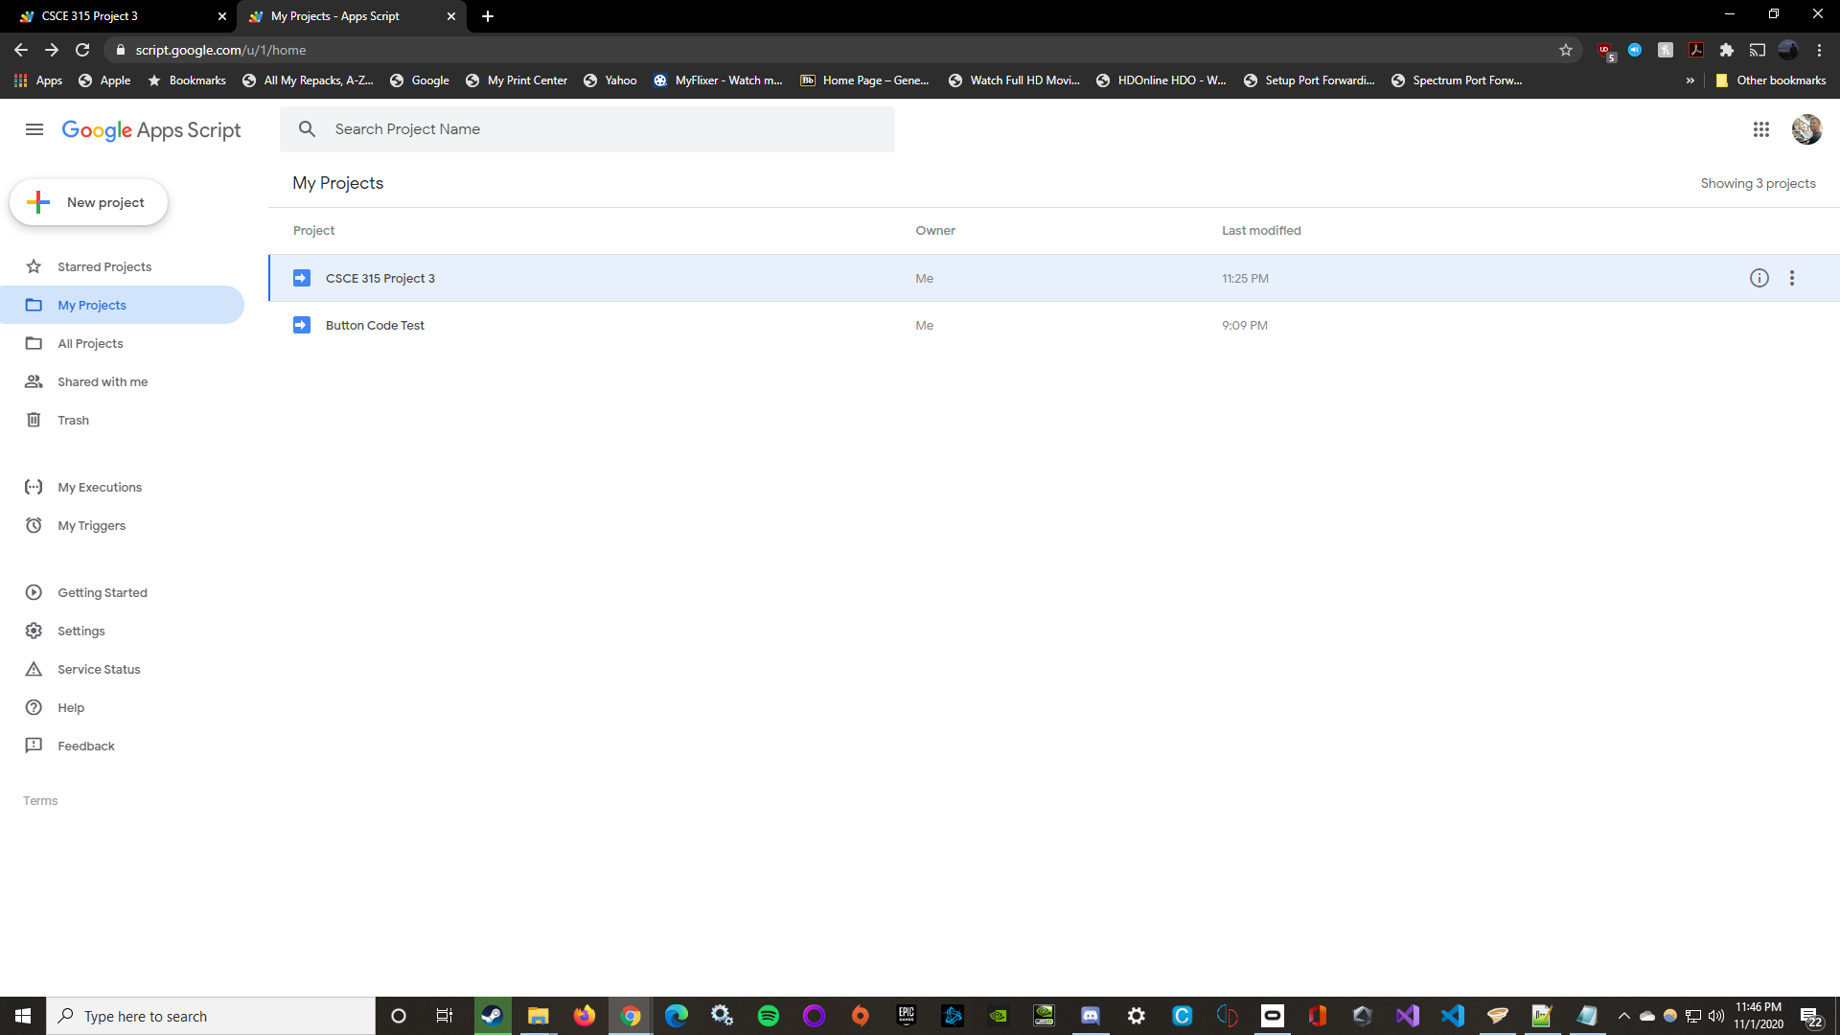

Click “File”, “new” and click “script file”

Name the script file “Word_Analyzer”

Repeat this process for the the html file

Name the file “sidebar”

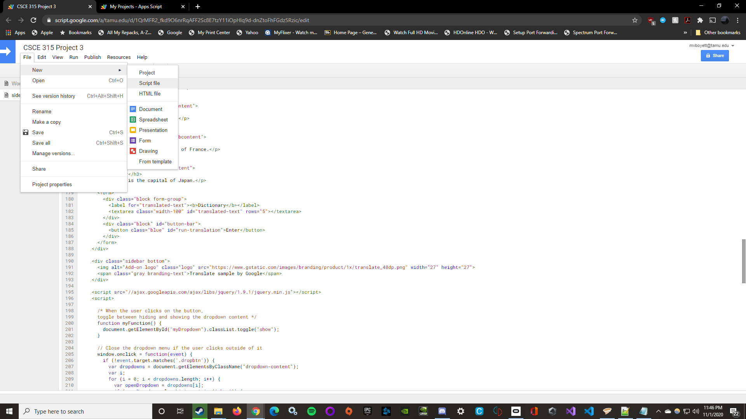

Copy and paste the code into the respective files

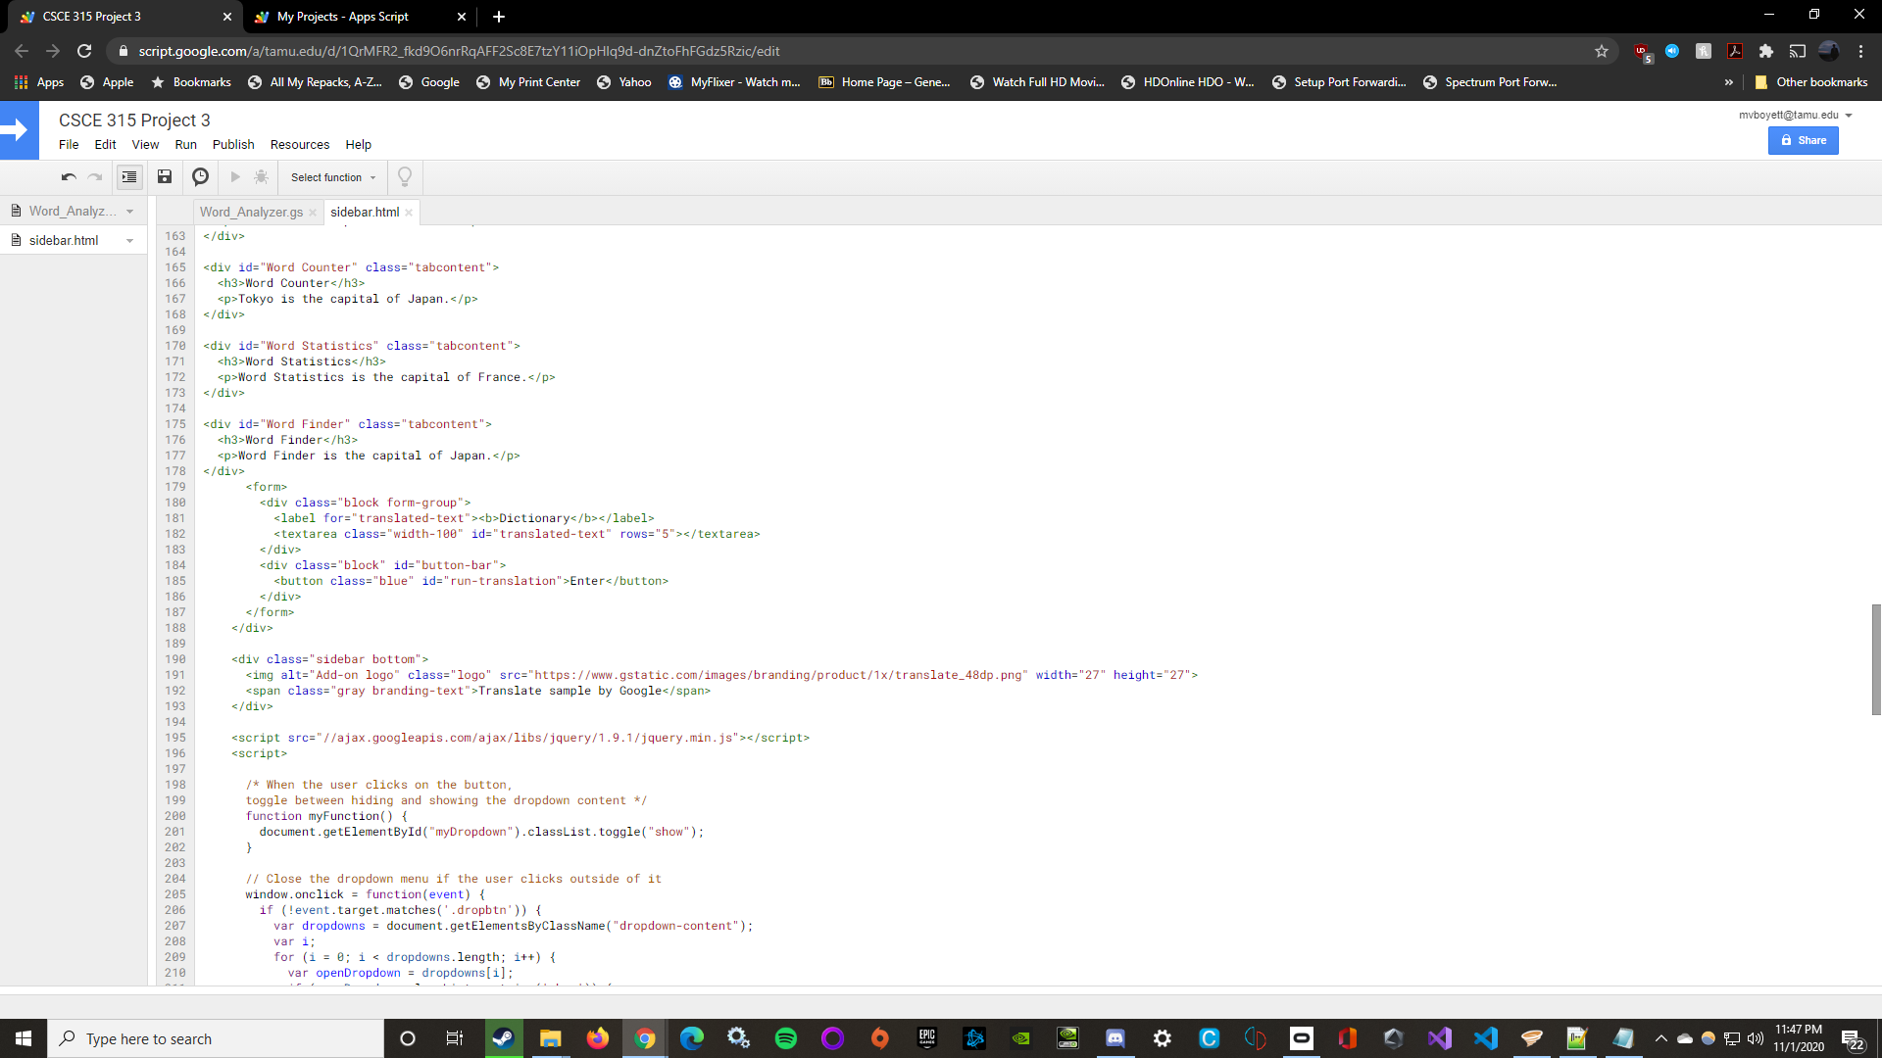

Click “run” and “test as add-on”

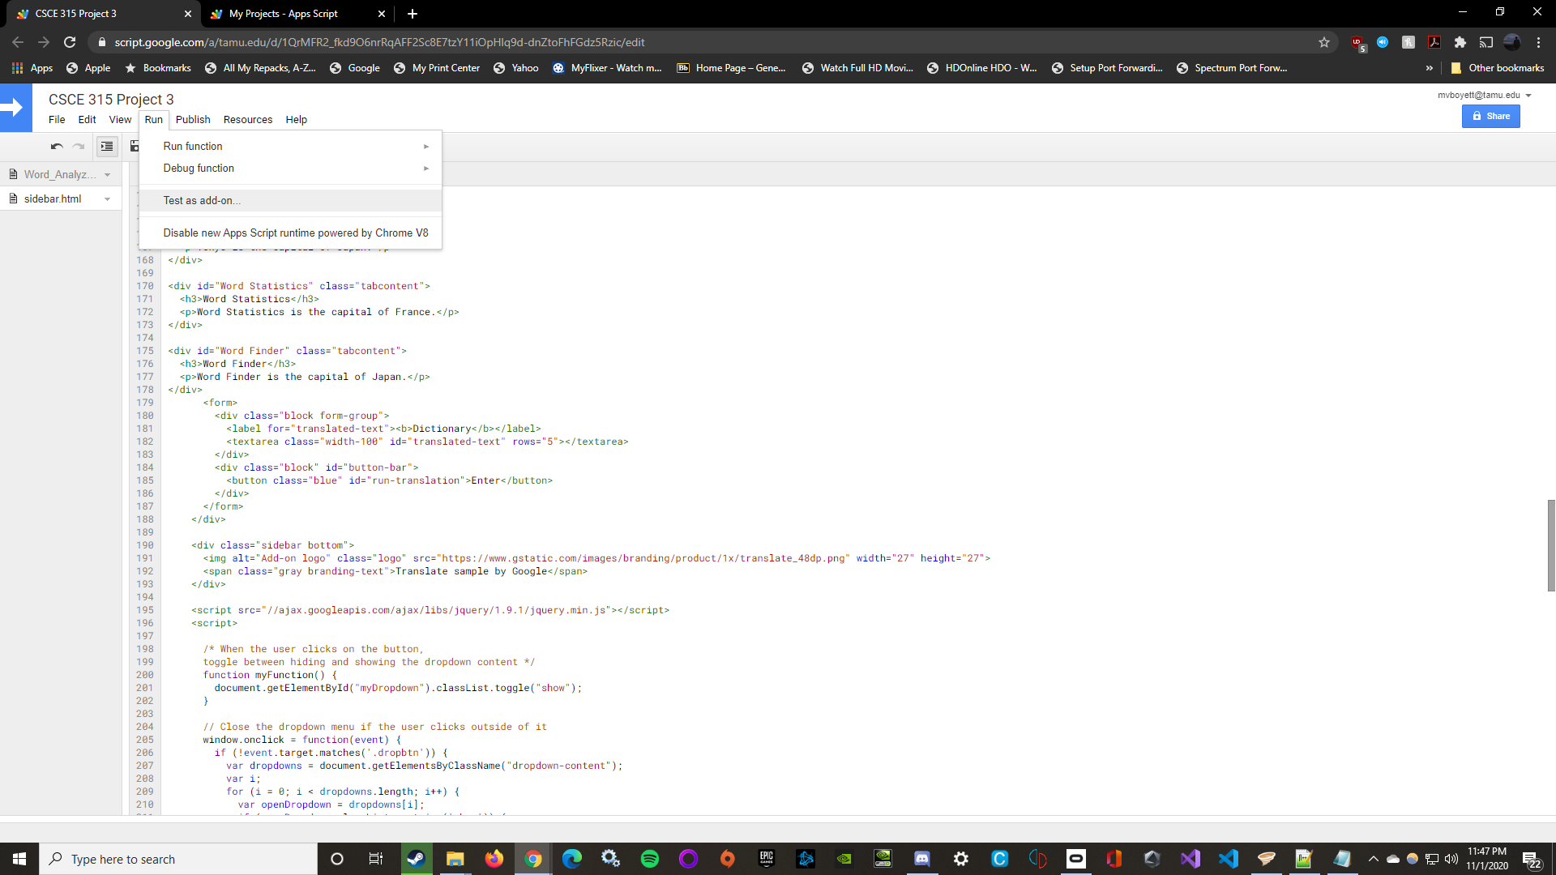

In the pop-up window, make sure

* “Test with latest code” and “Installed for current user” are selected
* Then select doc and choose whatever document you want to use your toll on

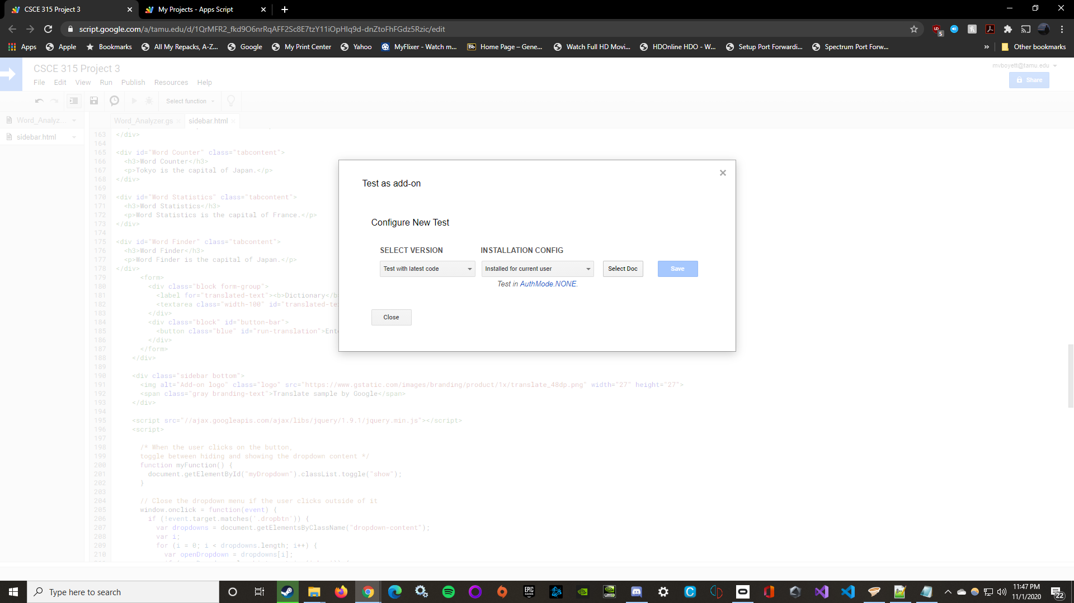

Click the “latest build” option” and then click “test”

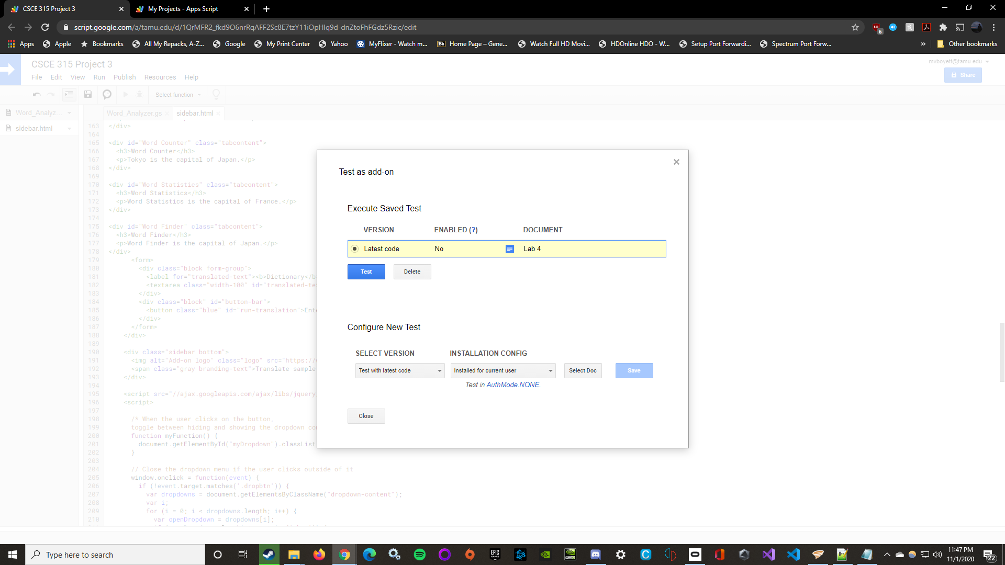

In your chosen Google Doc, click “Add-ons” in the top ribbon, click on your project name, and click “start”

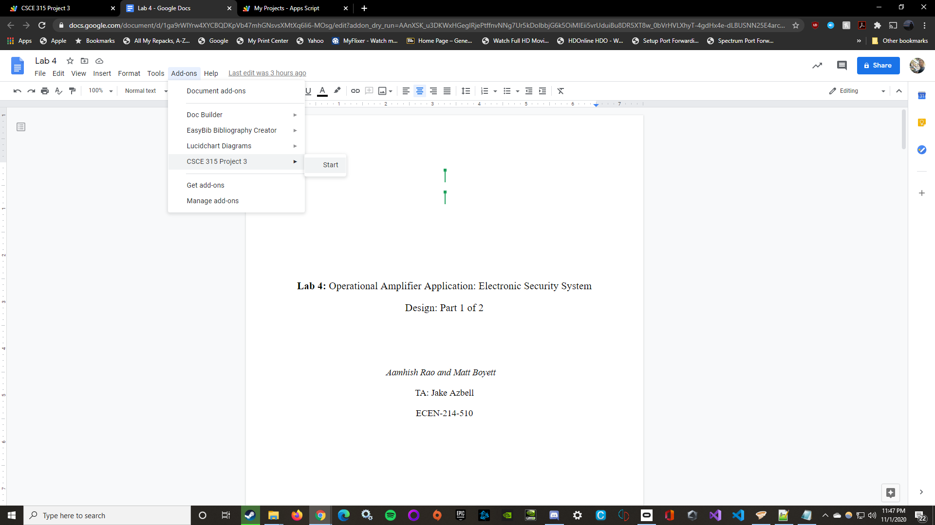

Click “Yes”

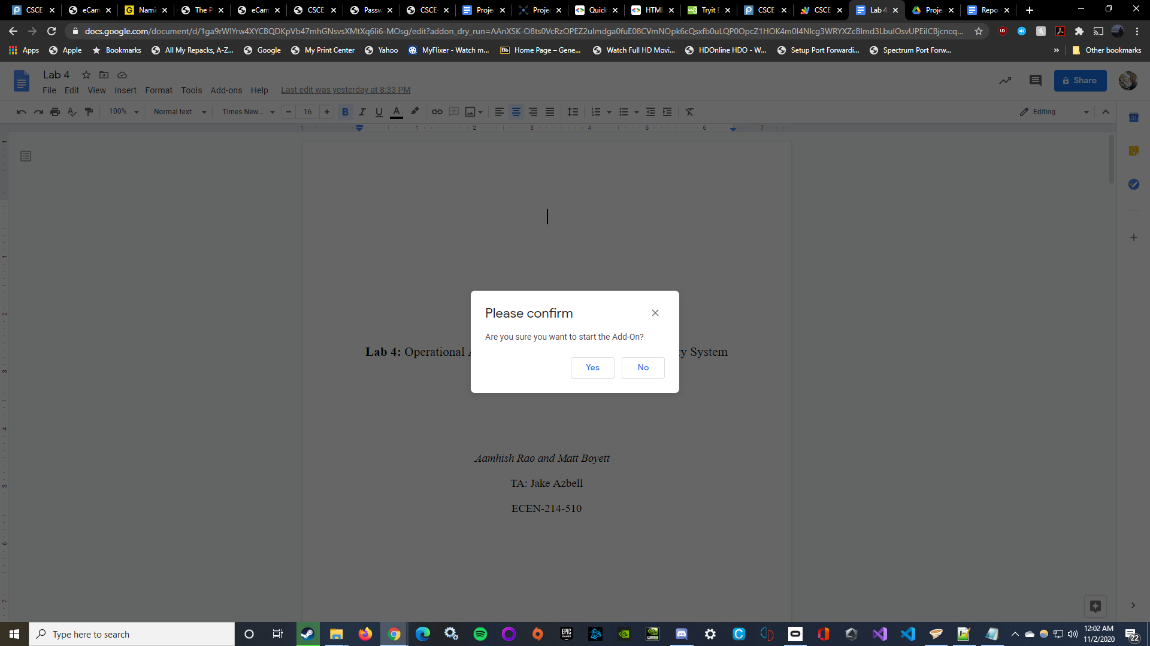

Click “Ok”

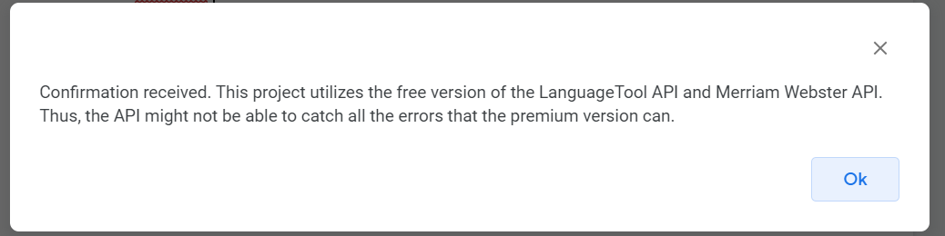

And here is the add-on! Just choose which function you want to use.

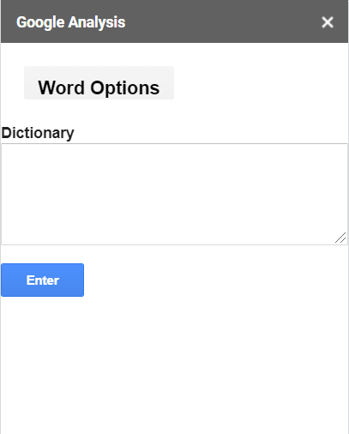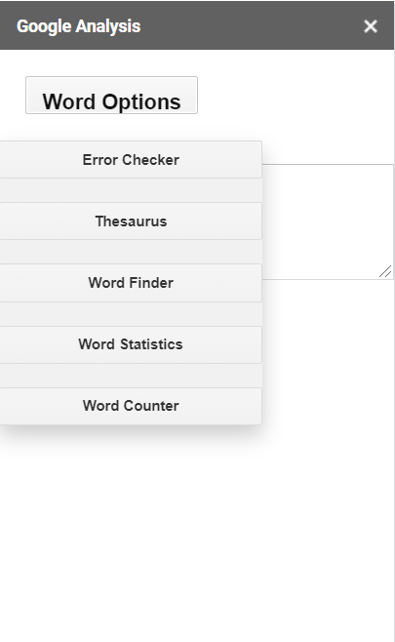

Code Updates based on User Study

The user study was a very helpful experience for improving our UI. We received critiques that our interface was not only barebones but also not incredibly cohesive or easy to understand from a new user perspective. On the left was our old UI and on the right is our current UI. We changed the placement of our output and text input boxes, the buttons at the top were removed, and the placement of the buttons has been rearranged to create a more user friendly experience.

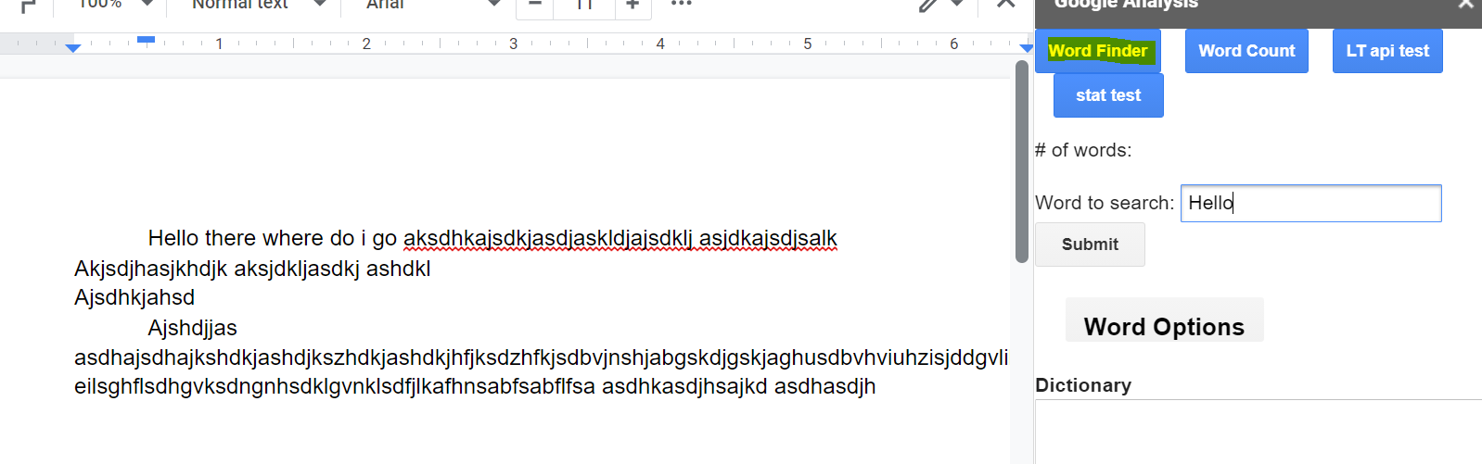 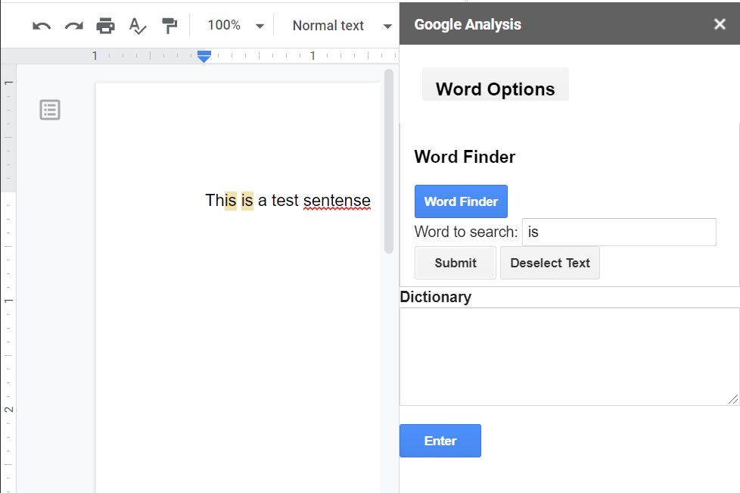

Functions

**Error Checker:**

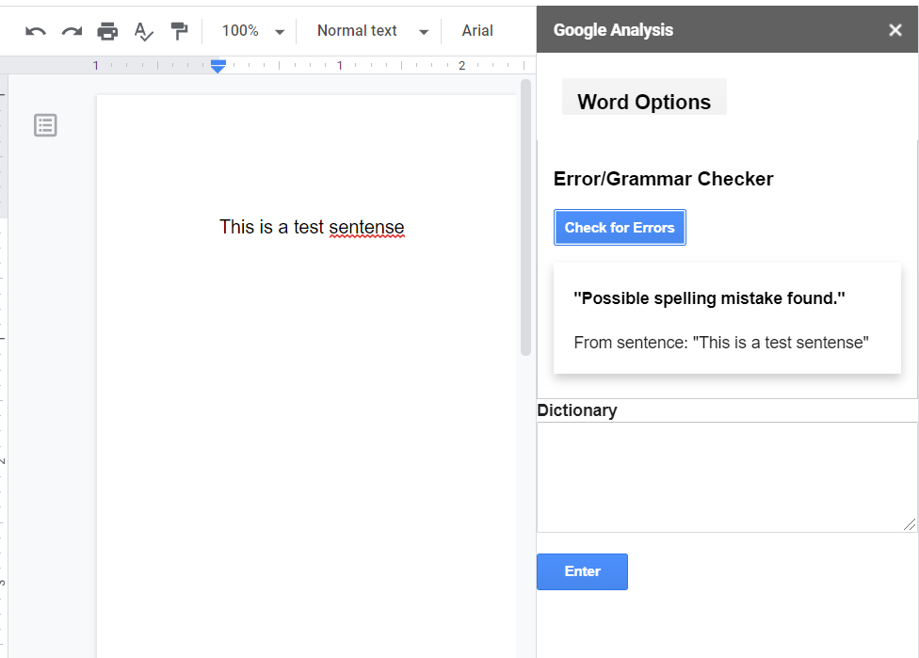

**Word Counter:**

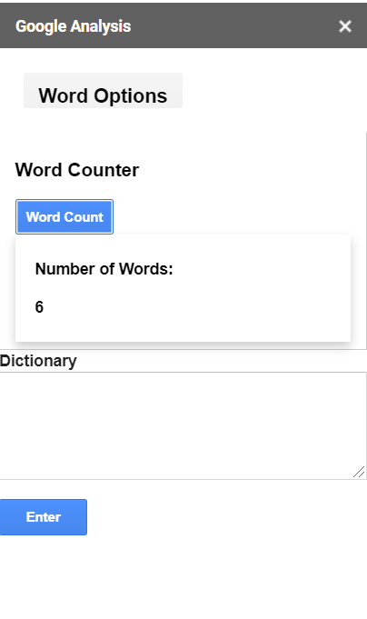

**Dictionary:**

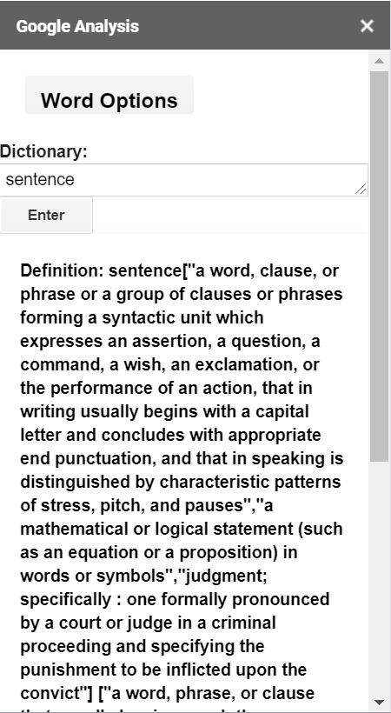

**Thesaurus:**

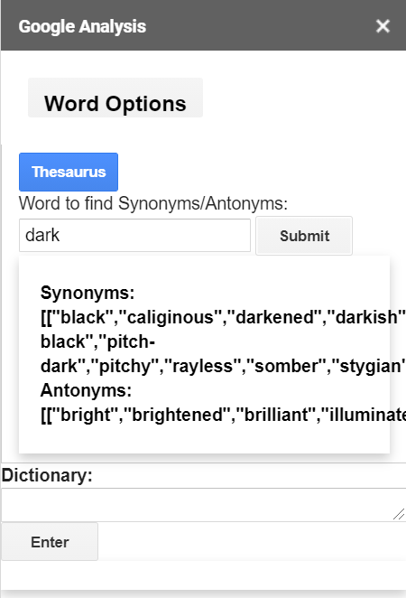

**Word Finder:**



**Word Statistics:**

